Manual
Thank you for purchasing this Asset, please follow the instruction chronologically. Alternatively, you can check our online video-guide.
As soon as you Import this package, you will end up with a few errors, but don’t worry, we will solve these errors and it should be quite straight forward!
If you are NOT using Text-Mesh-Pro (TMP) in your project
- Download TMP Window > Package-Manager.
- Import TMP Essential Resources (Fig.1)
- Import TMP Essentials and Extras (Fig.1)

Fig.1
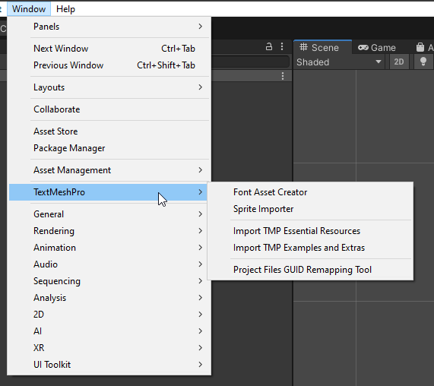

- If you are already using TMP in your Project, move onto the next step.

Checking TMP Build Version

- Check what version of TMP you are using. You can do this by Window > Package-Manager as follows:
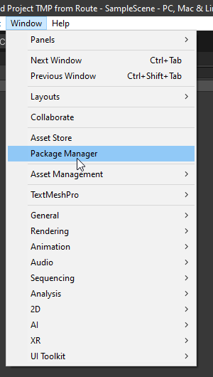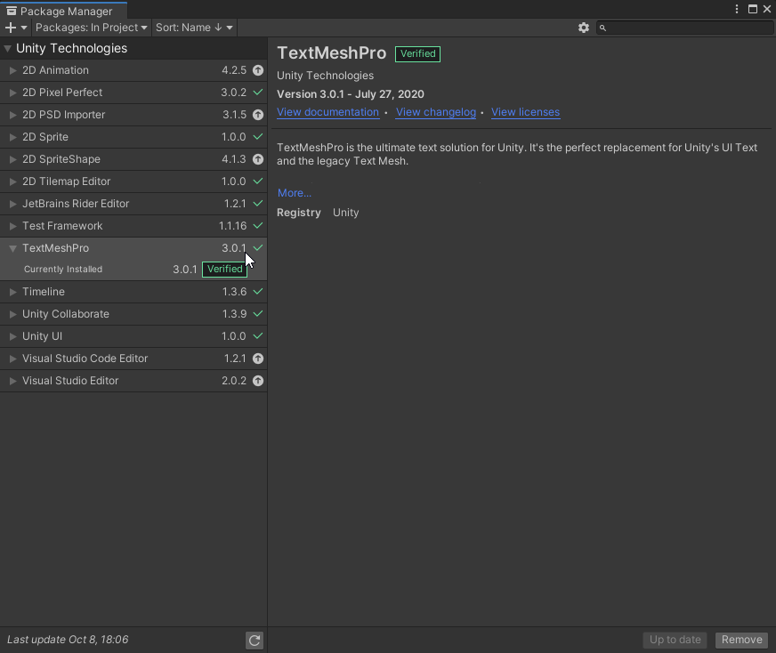

Note: The version in the given example is: “3.0.1”

Amending TMP

Note:
For this asset to work we need to make small Amendments to TMP, these will not affect any other projects that use TMP so there is no need to worry. You can continue to use TMP as usual even after these amendments as long as you add the tag “Blocker” to your projects.
TMP Version 3.0.1 Amendment instructions
- Copy the following destination and Paste it into “My Computer” / “This PC”:

C:\Users\%username%\AppData\Local\Unity\cache\packages\packages.unity.com\com.unity.textmeshpro@3.0.1\Scripts\Runtime\TMP_Dropdown.cs

Like so:
Paste:
Make sure there is no space before or after the link, if there is, highlight it and delete it:
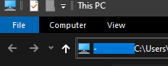
- Next, Press “Enter”. This Should Open TMP_DropDown.cs Script.

Amending TMP-DropDown

- Copy the following function “private void ImmediateDestroyDropdownList()”
- Press “Ctrl + F” while on the DropDown Script and paste the above function:

Like this:
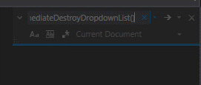

- After you find the function, Make It “public”.
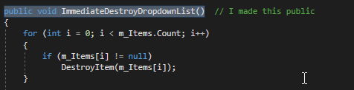
- Copy the following function “protected virtual GameObject CreateBlocker(Canvas rootCanvas)”
- Repeat Step (2), and find the function.
- Add to the function, the following line “blocker.tag = "Blocker";”
Like this:
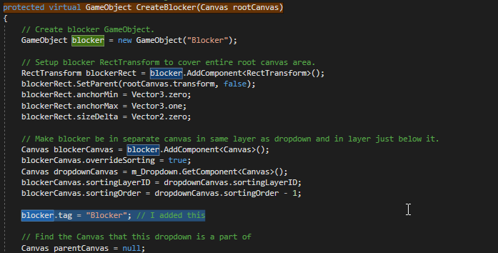
- And now Save it with the new changes.
Amending TMP-InputField

- Similar to last task; Copy the following destination and Paste it into “My Computer” / “This PC”: this will open the TMP_InputField.cs script.

C:\Users\%username%\AppData\Local\Unity\cache\packages\packages.unity.com\com.unity.textmeshpro@3.0.1\Scripts\Runtime\TMP_InputField.cs

- Search for the following function “public void DeactivateInputField(bool clearSelection = false)”
- Add the following code right before this function:
public bool SkipDeactivation = false; //I Added this
public void SkipDeactivationFunction(bool state) //I Added this
{
SkipDeactivation = state; //I Added this
}
Like this:
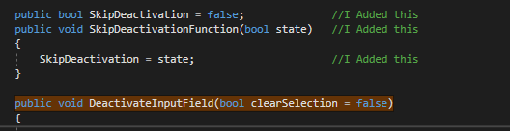
- Add the following code in the function, but must be right at the start of the function:
if (SkipDeactivation) //I Added this
{
return; //I Added this
}

Like this:
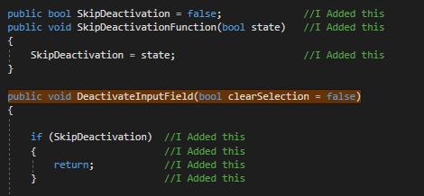
- And now Save it with the new changes.
Applying these Changes to the Project files

- Copy the following destination and Paste it into “My Computer” / “This PC”:

C:\Users\%username%\AppData\Local\Unity\cache\packages\packages.unity.com\com.unity.textmeshpro@3.0.1\Scripts\Runtime

- Copy the following two files that you amended.

File 1:

File 2:
- Paste Both files into your project files in the following location:

“ProjectFileName>Library>PackageCache>com.unity.textmeshpro@3.0.1>Scripts>Runtime”
Note: if asked to override old files, please do override.

- Reload your Project. And the errors should now be gone! Note; you only need to do this once per version of TMP, next time you create a new project with the same TMP version, it will use the amended version!

Creating Blocker tag
Unfortunately, this asset does use one tag slot, so please add the Tag “Blocker”, Case sensitive. Inspector > Tag > Add Tag

Like this:
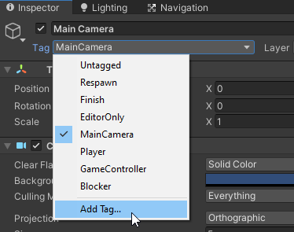

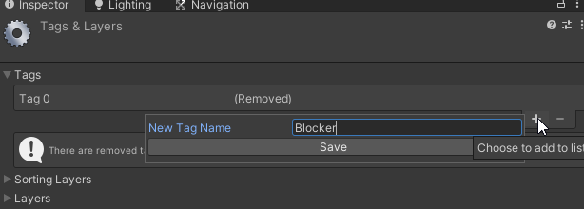

- And Click the Save button!

Using the Asset

Finally, you’re ready to use the Asset!
The following shows you how to use the asset, however, there is a separate video-guide on this as well that may explain it more clearly.
- Drag the “SearchDropDownManager” prefab to you canvas of interest.
- Right Click and “Unpack Completely”

Like So:
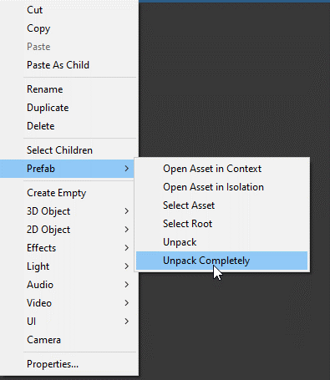

- There are three main ways to use this asset:
- By referencing Drop Down List (Use this if you have your own drop down menu that you want to apply this search function)
- By Manual Input Via Inspector (this is a quick way to make a search function and a drop down menu that you can populate from inspector)
- By Script Population (this is a way to populate a new dropdown menu, and this way is recommended if you have a large drop down, as you can just copy a string into the script

By referencing Drop Down List
- Reference your own Drop Down List into the SearchDropdownManager:
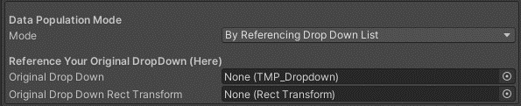
Like so:
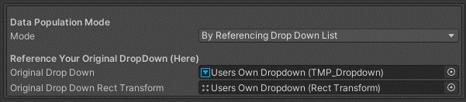

By Manual Input

- This is a fast and effective way to make small drop downs and search functions like so:
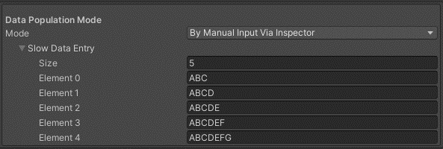
Resulting in:
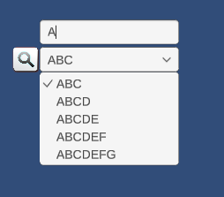

By Script Population

- User the provided script named “PopulateSearchingData” to populate your drop down:
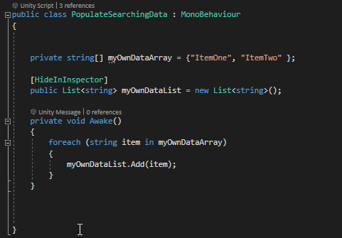
Which Results in:
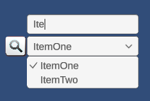

For Any Questions Please Email me on: MathsPlusGames@gmail.com

